PROCESS CONTROL APPLICATION
Verification Report

1. Report Purpose
This report documents the verified installation and execution of the Process Control Application in an English user interface. The software was tested through the New workflow, the Process Analysis tab, and the Process Improvement tab by using event log data and PNML model files.
2. Verified Environment
Operating environment: Windows desktop environment with Python, required libraries, and Graphviz available from Command Prompt.
3. Required Commands
python --version
pip --version
python -m pip install -r requirements.txt
dot -V
py main.py
4. Tested Input Configuration
The verified setup used the following mapping and interpretation settings.
Field | Verified value
Case ID column | case:concept:name
Activity column | concept:name
Timestamp column | time:timestamp
Recorded at | end
Time unit | Day

5. Process Setup
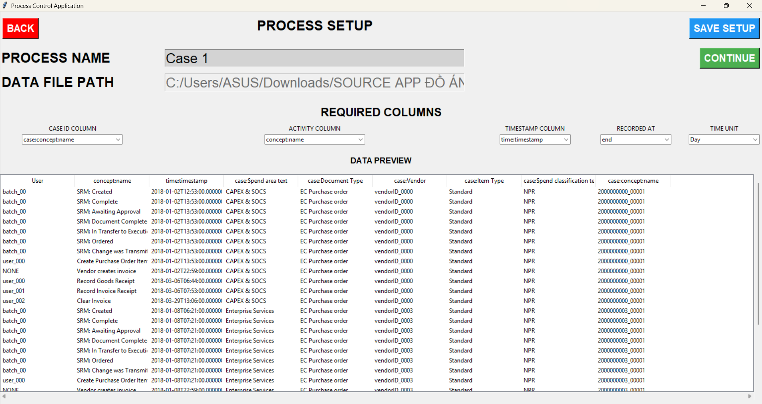
Figure 1. Process Setup screen with the verified column mapping and data preview.
6. Process Analysis Overview
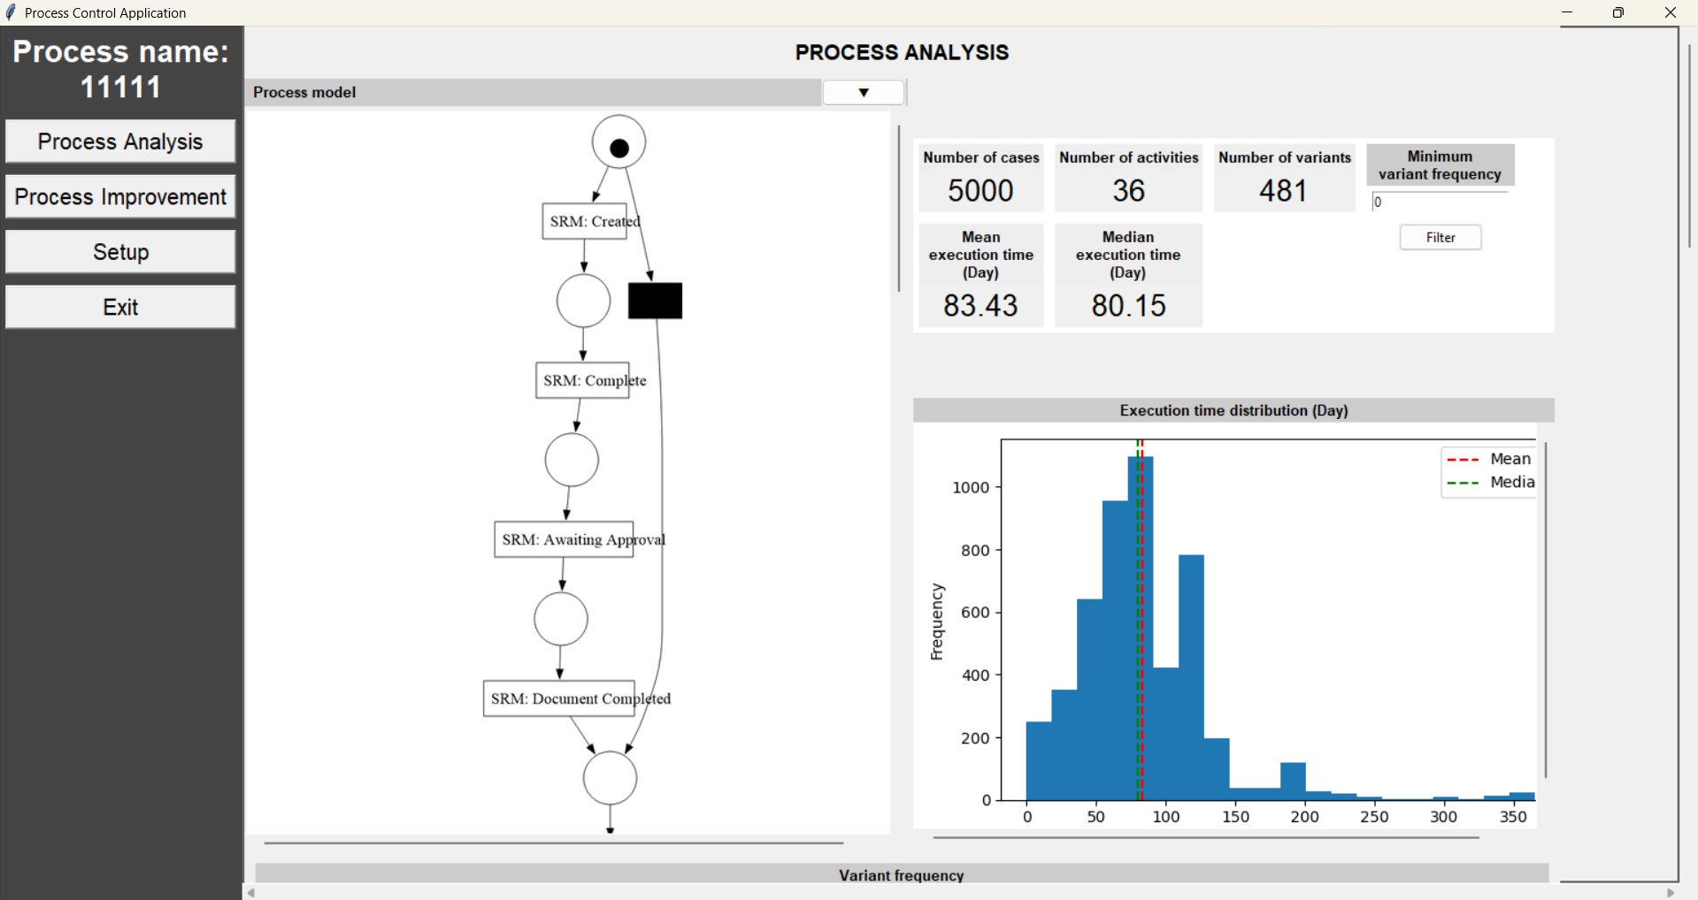
Figure 2. Process Analysis overview with the Petri Net model, KPI cards, and execution-time distribution chart.

7. Variant Frequency
The variant-frequency table lists the most frequent execution paths discovered in the log and supports inspection of dominant process paths.
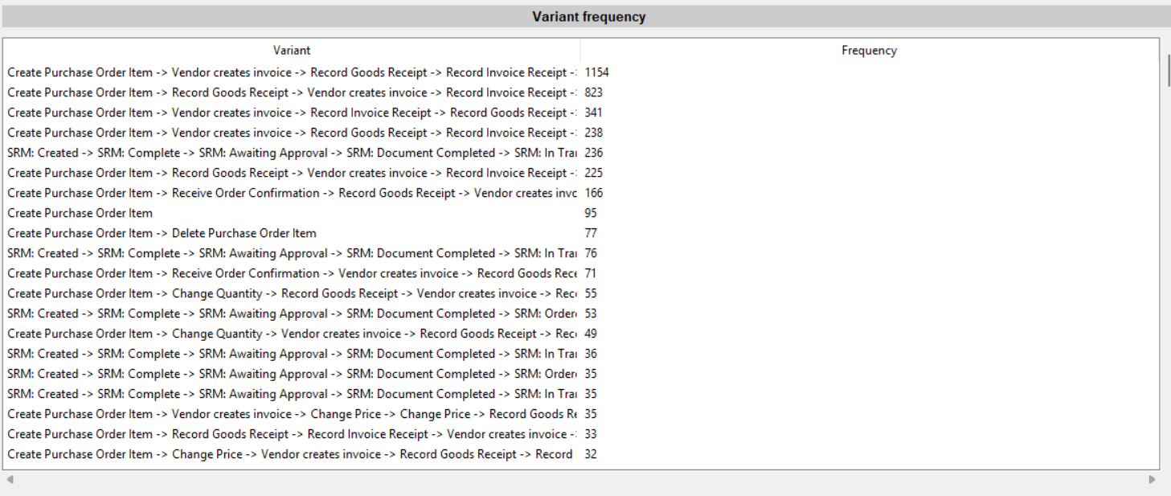
Figure 3. Variant-frequency table in the Process Analysis tab.
8. Activity Execution Count Table
The activity execution count table shows how many times each activity occurs across cases and supports basic rework inspection.
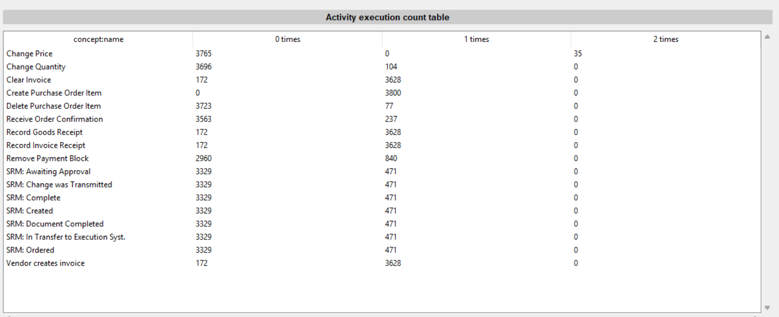
Figure 4. Activity execution count table.

9. Analytical Charts in the Process Analysis Tab
The verified run displayed the frequency-by-factor chart, the cycle-time chart, and the throughput-time chart in English, together with their ranking tables.
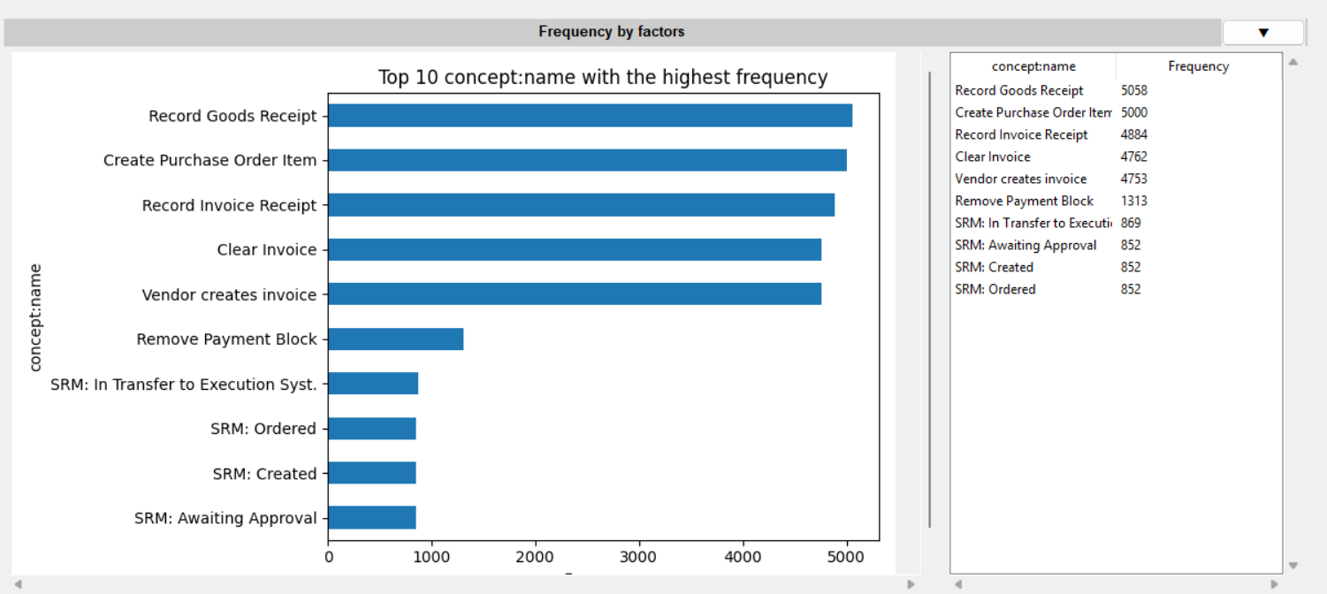
Figure 5. Frequency-by-factor chart and ranking table.
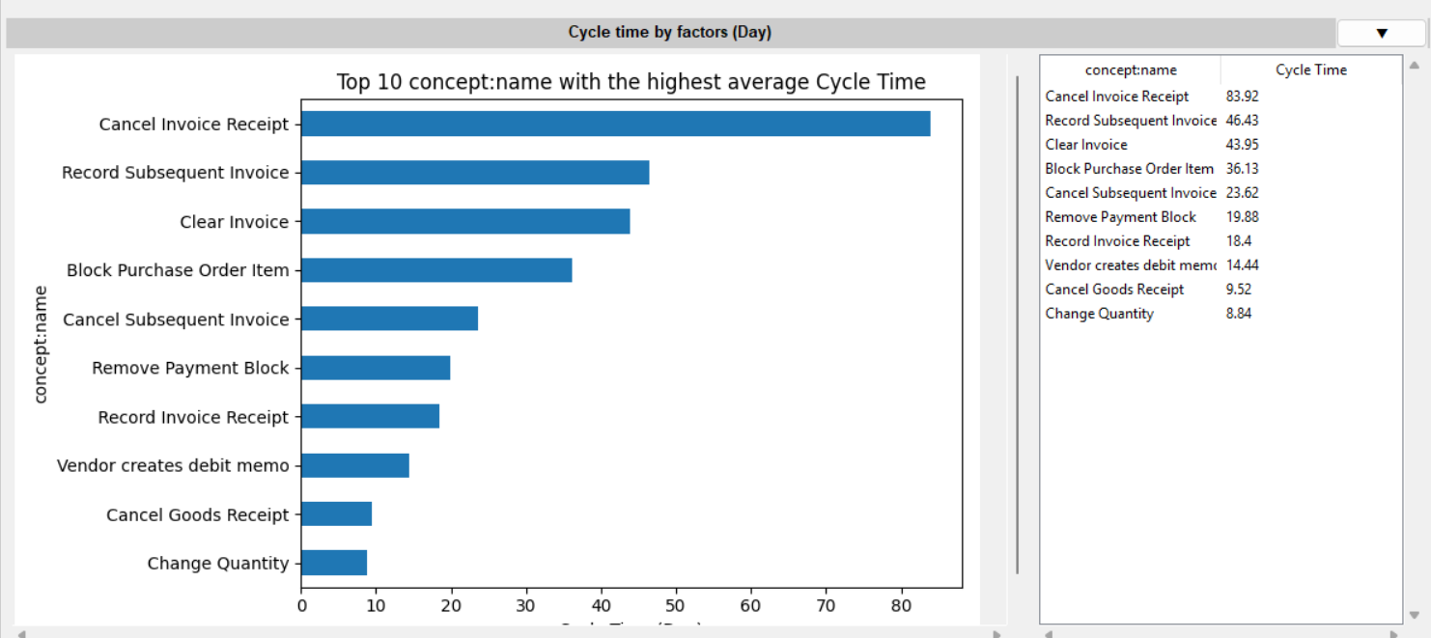
Figure 6. Cycle-time-by-factor chart and ranking table.
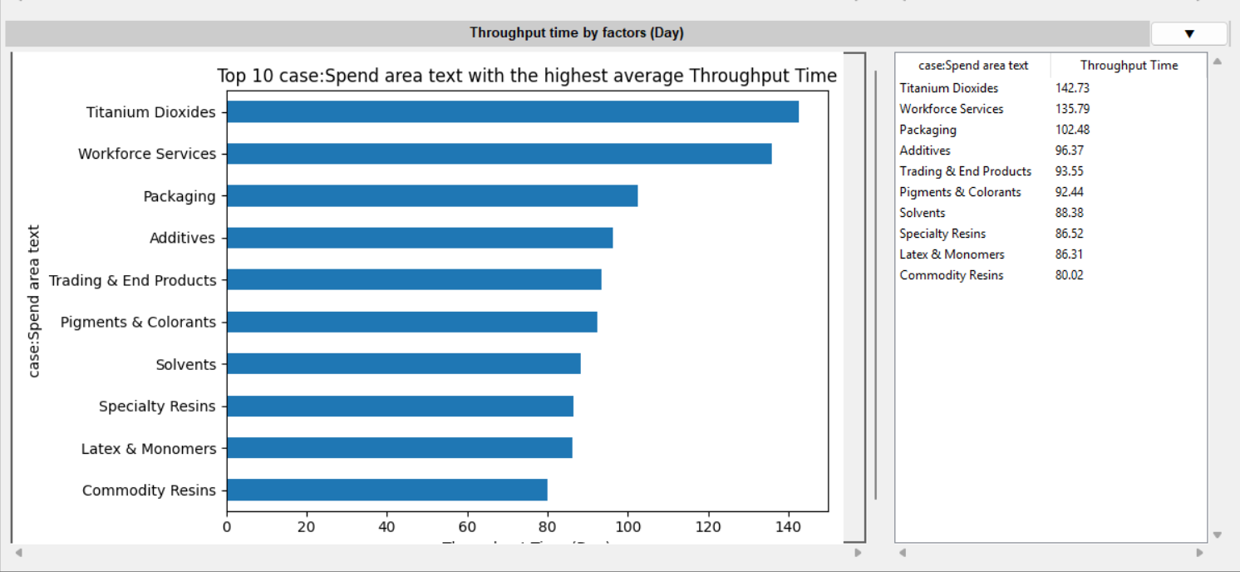
Figure 7. Throughput-time-by-factor chart and ranking table.

10. Process Improvement Tab
The Process Improvement tab was verified by loading one current model and one improved model from PNML files. The application displayed both models side by side and then produced model-comparison outputs below the model area.
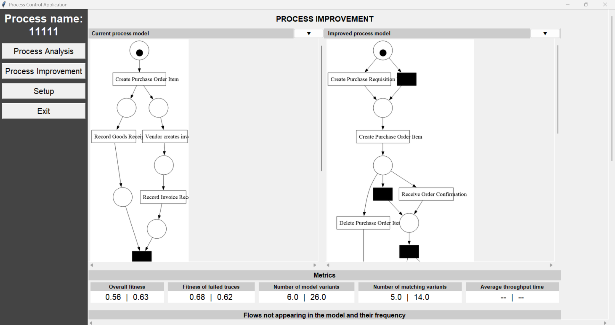
Figure 8. Process Improvement overview with the current and improved process models loaded from file.
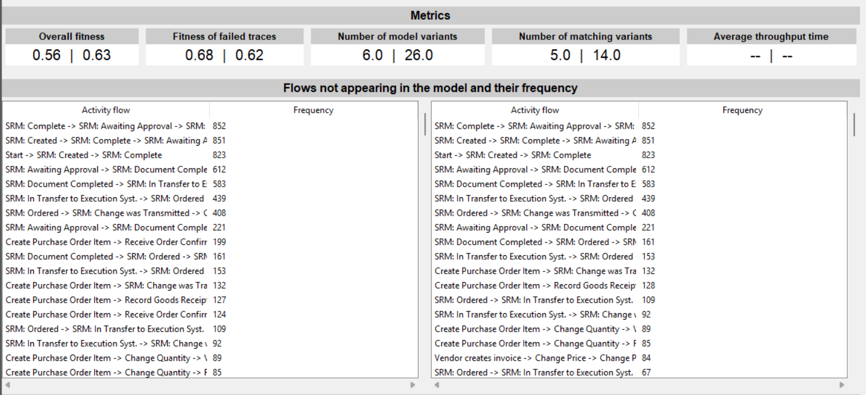
Figure 9. Comparison metrics and activity-flow tables in the Process Improvement tab.

11. Cycle Time by Previous Activity
The Process Improvement tab also displayed the cycle-time table by previous activity and activity for the loaded models.
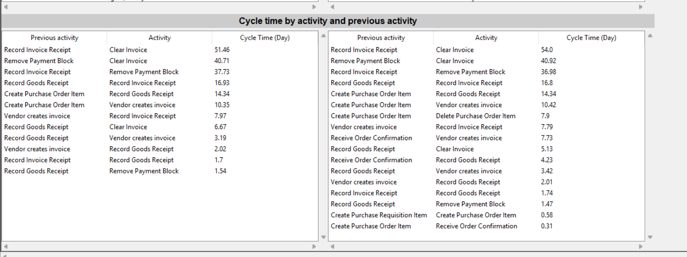
Figure 10. Cycle time by previous activity and activity in the Process Improvement tab.
12. Verified Functional Scope
- The application launches from Command Prompt with the command py main.py.
- The New workflow loads a new event log and opens the setup screen.
- The setup screen supports the tested mapping for case ID, activity, timestamp, recorded-at mode, and time unit.
- The Process Analysis tab displays the model view, KPI cards, the execution-time chart, the variant-frequency table, the activity execution count table, and factor-based analytical charts.
- The Process Improvement tab loads two PNML files and displays side-by-side models, comparison metrics, missing-flow tables, and the cycle-time-by-activity-and-previous-activity table.
- The Save Setup function is available from the setup screen.
13. Note
This report documents the functions that were directly verified in the tested run shown by the included screenshots. The package is prepared in English for submission and contains the source code, documentation, sample data, and verified screenshots used in this report.

